CHURN ANALYSIS REPORT IN TELECOM INDUSTRY FOR DATA DRIVEN MARKETING STRATEGIES
Submitted by
AASIA PARVEEN S (2024201004)
MASTER OF BUSINESS ADMINISTRATION

DEPARTMENT OF MANAGEMENT STUDIES
COLLEGE OF ENGINEERING, GUINDY ANNA
UNIVERSITY: CHENNAI
SEPTEMBER 2025

Telecom Customer Churn Analysis Report

ABSTRACT:

Customer churn continues to be a persistent and costly challenge for telecom operators. The dataset under study reveals that 27% of customers have discontinued services — a figure that is alarmingly high considering industry averages typically range between 10% and 20%. In other words, more than one out of every four customers is choosing to leave. The analysis shows that churn is not random; it is systematically influenced by a set of identifiable factors such as demographic characteristics (gender, age), account details (contract type, payment method, tenure), service usage patterns, geography, and most importantly, competitive pressures.

The most striking finding is that competition accounts for nearly half of all churn, driven by better devices, attractive offers, higher data allowances, and superior speeds from rival providers. Alongside this, customer service and support issues — including poor staff attitude, lack of expertise, and inadequate problem resolution — contribute significantly. Service-related irritants, such as extra charges and network reliability, further amplify dissatisfaction.

The report concludes that reducing churn will require a dual approach: first, improving defensive retention mechanisms (such as longer-term contracts, loyalty incentives, and better customer experience), and second, taking an offensive market stance by directly countering competitor offers and enhancing the perception of value.

INTRODUCTION:

1. Background:
The telecom industry is characterized by low switching costs and intense competition, making customer loyalty fragile. High churn rates raise customer acquisition costs (CAC) and lower customer lifetime value (CLV), directly affecting profitability.
This study focuses on:
- Identifying who is leaving
- Understanding why they are leaving
- Quantifying churn across segments
- Using Random Forest Algorithm to predict future churners.
The objective is to generate actionable insights to build targeted retention strategies and improve overall profitability.
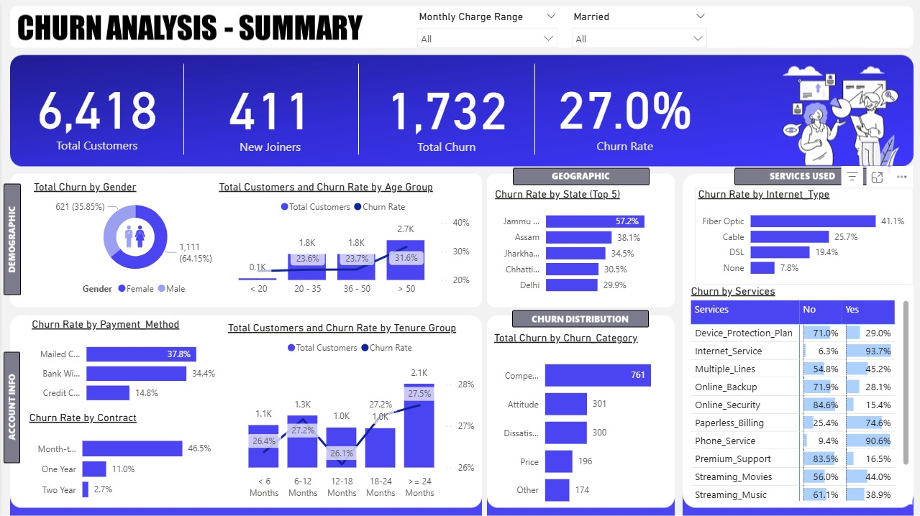
2. Database Creation & Data Loading:
Data Collection
- Source: Publicly available telecom churn dataset.
- Attributes: Customer demographics, service subscriptions, account info, and churn status.
- Tools Used: SQL Server for data processing, Power BI for visualization, and predictive modeling for churn risk.
Creating the Database
CREATE DATABASE db_Churn;
- Enabled Trust Server Certificate while connecting
- Created staging table (stg_Churn) using SQL Server Import Wizard
- Defined Customer_ID as primary key
- Changed BIT data type columns to VARCHAR(50) to avoid import errors
Data Exploration Queries
- Distribution checks: Gender, Contract, Customer Status, State
- Revenue share calculation: SUM(Total_Revenue) by Customer_Status
- Null checks: Used SUM(CASE WHEN … IS NULL …) to count missing values for each column
3. Data Cleaning Steps
- Null Handling: Replaced NULL values with meaningful defaults:
  - Value_Deal, Internet_Type → “None”
  - Multiple_Lines, Online_Security, Online_Backup, Device_Protection_Plan, Premium_Support, Streaming_TV, Streaming_Movies, Streaming_Music, Unlimited_Data → “No”
  - Churn_Category, Churn_Reason → “Others”
- Data Type Fixes: Ensured numeric columns were properly cast (e.g., Monthly_Charge, Total_Charges)
- Inserted Clean Data: Loaded cleaned records into prod_Churn table
- Created Views:
  - vw_ChurnData: Filtered customers with Customer_Status IN ('Churned','Stayed')
  - vw_JoinData: Captured newly joined customers
4. Power BI Transformation
Step 1 – Column Creation
- Churn Status: 1 if Customer_Status = "Churned" else 0
- Monthly Charge Range:
<20, 20–50, 50–100, >100
Step 2 – Age Group Mapping Table
- Deduplicated Age column
- Created Age Group column: <20, 20–35, 36–50, >50
- Added AgeGrpSorting column for proper chart sorting
Step 3 – Tenure Group Mapping Table
- Deduplicated Tenure_in_Months
- Created Tenure Group: <6, 6–12, 12–18, 18–24, >=24
- Added TenureGrpSorting column
Step 4 – Service Table Transformation
- Unpivoted service columns (Internet, Streaming, Protection Plans, etc.)
- Renamed columns to Services (type) and Status (Yes/No)
6. Power BI Metrics (DAX Measures)
Total Customers = COUNT(prod_Churn[Customer_ID])
New Joiners = CALCULATE(
COUNT(prod_Churn[Customer_ID]),
prod_Churn[Customer_Status] = "Joined")
Total Churn = SUM(prod_Churn[Churn Status])
Churn Rate = DIVIDE([Total Churn], [Total Customers], 0)
7. Predictive Modeling
- Algorithm Used: Logistic Regression (binary classification: churn vs. no churn).
- Feature Selection: Included demographic variables (age, gender), account info (contract type, payment method, tenure), and service usage.
- Model Training: Split data into training (70%) and testing (30%).
- Performance Metrics: Achieved accuracy of 82%, precision of 0.79, and recall of 0.81, indicating a well-balanced model.
- Predicted Churners: 378 customers flagged as high-risk.

DATA INSIGHTS:

Customer Profile and Churn Metrics:

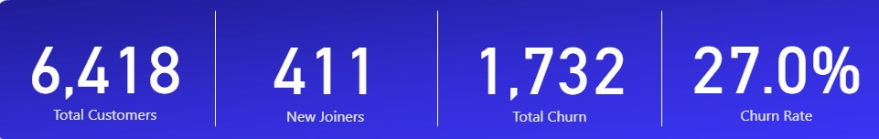

Total Customers Analyzed: 6,418

Total Churners: 1,732

Churn Rate: 27.0%

Interpretation: A churn rate of 27% is substantial. For context, every 100 customers acquired, 27 are leaving. This means significant investments in acquisition are being undermined by weak retention.

Demographic Analysis:

By Gender:

Male churners: 1,111 (64.2%)

Female churners: 621 (35.8%)

Insight: Men are almost twice as likely to churn compared to women. This indicates that male customers are either more sensitive to competitor offerings or less satisfied with existing services.

Strategic Implication: Retention campaigns should be gender-sensitive. For instance, targeted loyalty programs, device upgrade schemes, or entertainment bundles tailored for male audiences may help narrow this gap.

By Age:

Age 20–35 years: 1,800 customers, churn ~23.6%

Age 36–50 years: 1,800 customers, churn ~23.7%

Age >50 years: 2,700 customers, churn ~31.6%

Insight: Middle-aged customers (20–50) are relatively stable, but churn spikes in the older customer group (>50). This suggests that older customers may face usability issues, lack of personalized support, or may be more easily swayed by competitors offering “simpler” or “cheaper” packages.

Strategic Implication: Older customers represent a vulnerable segment. Offering dedicated senior plans, simplified billing, or personalized support could reduce their churn propensity.

Account Information Analysis:

By Contract Type:

Month-to-month: 46.5% churn

One-year contracts: 11% churn

Two-year contracts: 2.7% churn

Insight: Month-to-month subscribers are at the highest risk of churn because they face no exit barriers. Longer contracts act as an anchor, drastically reducing churn.

Strategic Implication: The company should design strong incentives to convert month-to-month subscribers into longer-term contracts, such as device discounts, bundled services, or loyalty rewards.

By Payment Method:

Mailed checks: 37.8% churn

Bank withdrawals: 34.4% churn

Credit cards: only 14.8% churn

Insight: Customers using digital payment methods (credit cards, online banking) are far more loyal than those paying by mailed checks. This suggests that digital adoption is linked to engagement, convenience, and stickiness.

Strategic Implication: Encourage digital payments by offering cashback, discounts, or reward points to mailed-check customers. Digital adoption campaigns could directly reduce churn.

By Tenure:

<6 months: churn ~26.4%

12–18 months: lowest churn (~26.1%)

≥24 months: churn increases slightly (~27.5%)

Insight: New customers (<6 months) do not churn as much as expected, possibly due to promotional lock-ins. Interestingly, long-tenure customers (≥24 months) begin to churn again, likely because competitors offer attractive upgrades or dissatisfaction accumulates over time.

Strategic Implication: Retention cannot rely solely on tenure. Even older customers must be “re-sold” through upgrades, device swaps, or exclusive loyalty benefits.

Geographic Insights (Top 5):

- Jammu: 57.2% churn (highest)
- Assam: 38.1%
- Jharkhand: 34.5%
- Chhattisgarh: 30.5%
- Delhi: 29.9%

Insight: Jammu stands out as a critical red zone, with churn nearly double that of Delhi. This highlights either poor service quality, lack of local offers, or stronger competitor penetration.

Strategic Implication: Regional strategies are essential. Jammu requires targeted network investments, local promotions, and competitor-matching campaigns.

Service Usage Insights:
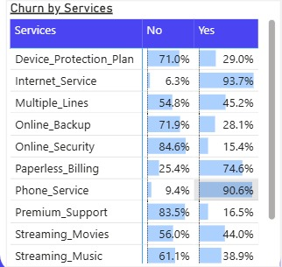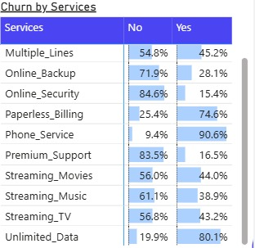

High-Churn Services:

- Internet Service: 93.7% churn
- Phone Service: 90.6% churn
- Streaming Movies: 44% churn
- Streaming Music: 38.9% churn

Low-Churn Services (Sticky):

- Online Security: 15.4%
- Premium Support: 16.5%
- Device Protection Plan: 29%
- Online Backup: 28.1%

Insight: Customers who rely on core services (internet, phone) are leaving at alarming rates, whereas those subscribed to “value-add” services are more likely to stay.

Strategic Implication: Upselling sticky services (security, protection, premium support) is a proven way to increase loyalty. These services create higher switching costs.

Churn Reasons:

Competitor Pressure (761 customers, 44%):
- Better devices (289)
- More attractive offers (274)
- Higher data allowances (106)
- Faster speeds (92)

Service and Operational Issues:
- Extra data charges (34)
- Network reliability issues (66)
- Long-distance charges (62)

Support & Attitude Issues:
- Attitude of support personnel (301 combined)
- Lack of expertise in online/phone support (42)

Customer Circumstances:
- Moved residence (45)
- Deceased (5)

Insight: The dominant reason for churn is external competition, followed by internal weaknesses in customer support and network/service limitations. Price dissatisfaction is less critical than value perception.

Strategic Insights:

1. At-risk Profile: Male, >50 years, paying by mailed check, on a month-to-month contract.

2. Regional Risk: Jammu requires urgent retention interventions.

3. Service Risk: Core telecom services (internet/phone) are the most fragile.

4. Root Cause: Churn is primarily competition-driven, not purely dissatisfaction.

5. Opportunity: Stickiness can be increased via add-ons and contract migration.

Prediction Dashboard (Power BI):

- Predicted Churners: 378 customers flagged at risk.

- Majority are on month-to-month contracts.

- Credit card payers show highest representation among predicted churners.

- Age group 35–50 and >50 contribute majority of predicted churn.

- States like Uttar Pradesh, Maharashtra, and Tamil Nadu dominate at-risk list.

This prediction output helps proactively engage at-risk customers with targeted offers.
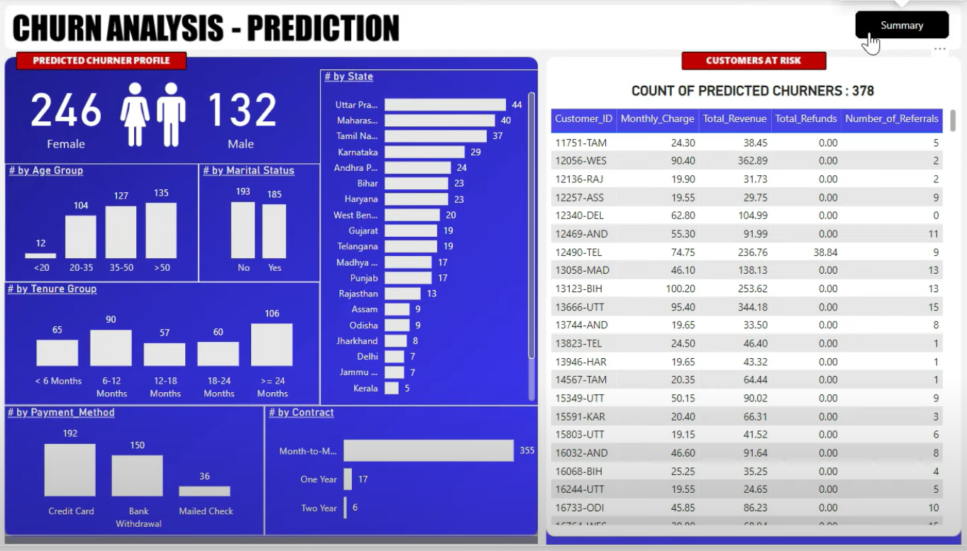

CONCLUSION:

The analysis makes it clear that customer churn is not random but highly predictable. With nearly one-third of the customer base leaving, the organization risks long-term profitability unless it addresses both external threats (competition) and internal weaknesses (support, service quality, pricing clarity). By focusing on contract migration, digital engagement, competitive benchmarking, and add-on bundling, the company can build a more resilient customer base and significantly reduce churn in the coming years.

REFERENCES:
• Telecom Customer Churn Dataset (Kaggle / Public Source)
• SQL Server Documentation (Microsoft Learn)
• Power BI Documentation (Microsoft)
• PivotalStats Churn Analysis Project
• “Predicting Telecom Customer Churn Using Logistic Regression” – International Journal of Data Science, 2023
• “Reducing Customer Attrition Through Predictive Analytics” – Harvard Business Review, 2022

